**Game Theory Notes – Nicholas Umashev**

Overview

Extensive Form (game tree)

Normal Form (strategic form)

Strategy and Notation

Expected Payoffs, Mixed Strategies, and Beliefs

Dominant Strategy

Best Response

Nash Equilibrium

Bertrand Model

The Ultimatum Game

Sequential Rationality and Subgame Perfection

Conditional Dominance

Cournot, Monopoly and Stackelberg Model

Industrial Organisation: Capacity Limits

Finitely Repeated Games

Infinite Repeated Games

Competitive Markets in Repeated Settings

Random Events & Incomplete Information

# Overview

* Game Theory: the study of strategic decision making by utilizing games that involve multiple players who are related to one another
  + The objective of game-theoretic modeling is to precisely sort through the logic of strategic situations—to explain why people behave in certain ways and to predict and prescribe future behavior
  + The goal of game theory is to figure out what strategies will be played and their payoff
* Games must satisfy four requirements:
  + 1) Rules
    - Move order (can be either sequential move or simultaneous move)
      * Simultaneous move: when players have to make their strategy choices simultaneously, without knowing the strategies that have been chosen by the other players (e.g. rock, paper, scissors)
      * Sequential move: where one player chooses their action before the others choose theirs and know the strategies that have been chosen by previous move takers (e.g. chess)
      * Defined by information set
    - Knowledge/Information set (can be either complete or incomplete knowledge)
      * Complete knowledge: knowledge about other players strategies and payoffs is available to all participants (e.g. chess) and there is a complete understanding of the game
      * Incomplete knowledge: knowledge about other players strategies and payoffs is not available to all participants (e.g. poker)
  + 2) Players
  + 3) Strategy set (list of all possible choices)
  + 4) Pay offs (with pay offs listed for every possible outcome)
  + Example: Chess has rules involving sequential move order and complete knowledge, white and black players, strategies are the legal chess rules, and the payoffs are win, lose, draw
* Rationality: each player behaves according to his preferences - maximizing one’s expected payoff
* Solution Concepts: prescriptions or predictions about the outcomes of games
* Issues of conflict and cooperation often arise simultaneously and overlap
  + Example: although the interests of a manager and worker may conflict regarding the worker’s wage, the parties may both prefer that the contract include a bonus for the worker to be granted in the event of exceptional performance on the job
* All games feature interdependence
  + Interdependence: when one person’s behavior affects another person’s well-being, either positively or negatively. Situations of interdependence are called strategic settings because, in order for a person to decide how best to behave, he must consider how others around him choose their actions
* There are two common forms in which noncooperative games are represented mathematically: the extensive form and the normal (strategic) form.

# Extensive Form (game tree)

* Extensive Form Representation: utilizes a ‘tree’, defined by nodes and branches, to graphically represent the strategic interaction between these two people.
  + Nodes: represent places where something happens in the game (such as a decision by a player). Represented by solid circles and typically labelled with an initial that signifies whose move it is in that point of the game
    - Decision Nodes: when players make decisions at these places in the game, all decision nodes are contained in an information set
    - Terminal Nodes: represent outcomes of the game with given payoffs — where the game ends
      * Each terminal node also corresponds to a unique path, through the tree, from the first decision node to terminal node
      * Each terminal must have a unique identifier
  + Branches: indicate the various actions that players can choose. Represented by arrows connecting the nodes
* Information Set Symbols: specifies the players’ information at decision nodes in the game
  + Dashed line: when a player cannot distinguish between two decision nodes(they are in the same set)
  + No symbol: information sets that consist of only one node
  + Arc: represents a continuous set of decisions
  + Example: Nodes b and e are their own separate information sets. Nodes c and d, however, are in the same information set
  + Assumptions
    - All nodes in an information set are decision nodes for the same player and only one decision is made at each information set
  + Example: production of bug movies described in textbook

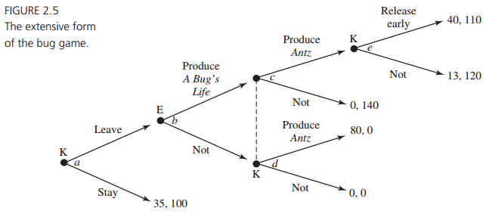

* Move Sequence
  + In an extensive form, we must draw one player’s decision before that of the other, but this does not necessarily correspond to the actual timing of the strategic setting. Moves can either be simultaneous or sequential - player 1 does not necessarily go first. Move order is indicated by information sets
  + Example: in this example, the moves are simultaneous. In the below figure, because firm 2 moves at the same time as does firm 1, firm 2 does not get to observe firm l’s selection before making its own choice. Thus, firm 2 cannot distinguish between its two decision nodes—they are in the same information set and therefore connected with a dashed line.

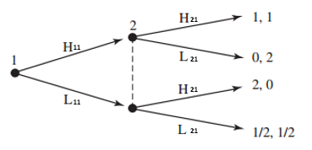

* Labelling Moves
  + All possible moves/decisions must be given a unique identifier in the form of: xia
    - x: the symbol used to label the decision taken
    - i: the player who makes this decision
    - a: the player’s decision order i.e. how many decisions did the player make before it
  + Note: only one unique identifier needs to be given per information set as, to the player, the moves are the same. This is still the case even though two terminals may have different payoffs
  + Example: in the above figure, H21, represents player 2’s first move and the decision to choose move H
* Five Game Tree Rules
  + Rule 1: every node is a successor to the original node and the original node is the only one with this property
  + Rule 2: each node, except the origin, has exactly one immediate predecessor. The origin has no predecessors
  + Rule 3: all branches must have different names
  + Rule 4: information sets contain nodes that all belong to the same player
  + Rule 5: all nodes that belong to the same information set have the same number of immediate successors and the actions must have the same label. Otherwise we would be insinuating that players can tell the difference between nodes in the same set
* Conversion of Normal Form to Extensive Form
  + Although there may be only one way of going from the extensive form to the normal form, the reverse is not true. For instance, in the below figure it is easy to convert extensive form to normal form, however this is not the case for converting normal form to extensive form
  + This is as, whilst the matrices do indicate how many information sets there are, they do not indicate the location of the information sets

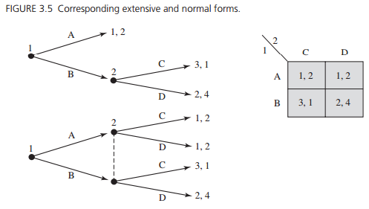

# Normal Form (strategic form)

* Normal(matrix) Form: models a situation in which players independently select complete contingent plans for an extensive-form game i.e. equivalent to real-time play of the extensive form
  + We can represent sequential and simultaneous move games using normal form
  + The strategy sets and payoff functions of the players fully describe a strategic situation, without reference to an extensive form
* Purpose: convenient way of describing the strategy spaces of the players and their payoff functions for two-player games in which each player has a finite number of strategies is to draw a matrix
* Structure
  + Consists of a set of players (1, 2, ..., n), strategy spaces for the players (S1, S1 , ..., Sn), and payoff functions for the players (u1 , u2, ..., un)
  + Each row of the matrix corresponds to a strategy of player 1, and each column corresponds to a strategy of player 2
  + Each cell of the matrix (which designates a single row and column) corresponds to a strategy profile and payoff
  + Inside a given cell the payoff vector associated with the strategy profile is listed, with player 1’s payoff listed first
* Chicken Example: two players drive automobiles toward each other at top speed. Just before they reach each other, each chooses between maintaining course (H) and swerving (D). If both swerve, they both save face and are satisfied. If only one swerves, then he is proved to be a wimp, whereas the other is lauded as a tough guy with steely nerves. If both maintain course, they crash and are each horribly disfigured. Represent the strategy profiles and their payoffs in normal form

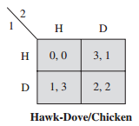

* Conversion of Extensive Form to Normal Form
  + Steps for conversion:
    - 1. Find how many information sets exist for player 1 and 2
    - 2. Find how large the strategy space is for the players: # of strategies in S1 and S2
    - 3. List the strategies in each player’s strategy set
    - 4. Find how large the total strategy space is: Ssize = S1 * S2
    - 5. List the elements in s: s = [(s1a; s2a), (s1b; s2a), (...)]
    - 6. Draw in normal form
      * Number of elements/size of strategy space = no. of columns/rows for play i
  + Example:

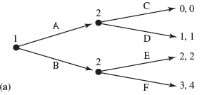

1. Find how many information sets exist for player 1 and 2

Player 1: 1

Player 2: 2

2. Find how large the strategy space is for the players: # of strategies in S1 and S2

Player 1: 2

Player 2: 4

3. List the strategies in each player’s strategy set

Player 1: S1 = [A, B] = [s1a, s1b]

Player 2: S2 = [(C, E), (C, F), (D, E), (D, F)] = [s2a, s2b,s2c, s2d]

4. Find how large the total strategy space is

Ssize = S1 x S2 = 2 x 4 = 8

5. List the elements in s

s = [(A; C, E), (A; C, F), (A; D, E), (A; D, F), (B; C, E), (B; C, F), (B; D, E), (B; D, F)]

6. Draw in normal form

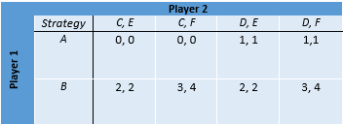

# Strategy and Notation

* Strategy: a strategy is a complete contingent plan for every information set
  + Complete contingent plan: a full specification of a player’s behavior, which describes the actions that the player would take at each of his possible decision points
  + Because information sets represent places in the game at which players make decisions, a player’s strategy describes what he will do at each of his information sets
    - Strategies are defined by information sets. Each strategy has to cover each information set, it has to define what you do at each set - even if one strategy is not possible given another
* Strategy Move: the possible choice taken
* Strategic Uncertainty: not knowing for sure what other players will do
* Strategy Profile: a set of strategies for all players which fully specifies the actions in a game
  + Strategy profiles must include one and only one strategy for every player and is contained in a strategy set
* Strategy Set/Space: a list of all possible choice combinations for a/all player/s
  + The strategy space size for all players is S = (S1 x S2 x … x Sn)
  + Formula: Suppose that player i has ιi many information sets and we will list the information sets as I = {1, 2, . . . , ιi}. And at each information set l, player i has σl many choices. Then the size of player i’s strategy space is:
    - 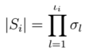
* Terminology and Notation
  + Si = the strategy set of player i (Si comprises all the possible strategies of player i in the game)
    - All possible strategies must be labelled with a unique identifier
      * Example: S1 = (s1a, s1b, s1c, and s1d) which are all the strategies for S1
    - The number of strategies in player i’s strategy set is equal to the number of decisions at each decision point 1 * the number of decisions at decision point 2* the number of decisions at decision point 3 and so forth
  + S-i  = the strategy set for everyone except player i (S−i = (s1; s2; …; si−1; si+1; …; sn))
    - Example: separating a strategy profile s into the strategy of player i and the strategies of the other players, we write s = (si ; s-i). For example, in a three-player game with the strategy profile s = (B, X, Y), we have s-2 = (B, Y)
  + S = the strategy set of all players (list of each player’s strategy for each other player’s strategy)
    - s = [(s1a; s2a), (s1a; s2b), (…)] = [(A; C, E), (A; C, F)
    - Remember to list the decision for each information set for every player even if that decision would not be available given other decisions
    - Note: (s1a; s2a) is a strategy profile in this example
  + sia = the single strategy of a player(i), indicated by a lowercase s with a unique identifier(a)
    - Example: sia ∈ Si is a strategy for player i in the game where s1 = a decision plan for every possible information set
  + ; or , = a semi comma is used to separate players, a comma is used to separate strategies
* Notation Example: in the entry advertising game, list the incumbent strategies and strategy set
  + 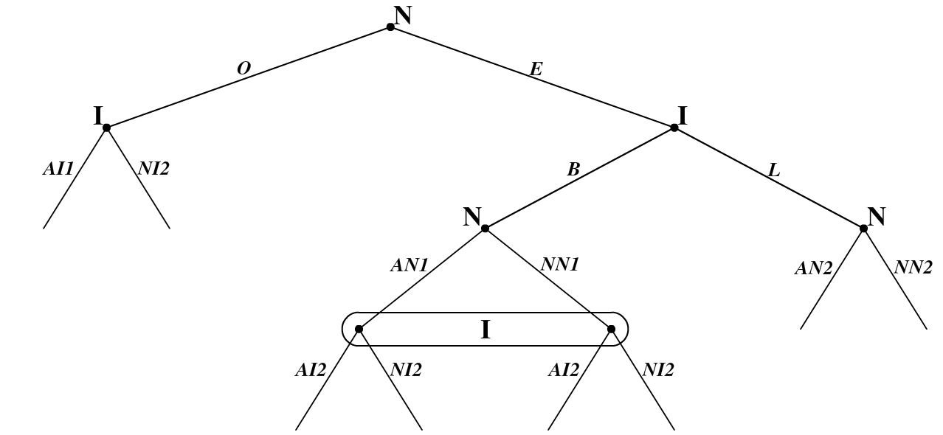
  + SI = [(B, AI1, AI2), (B, AI1, NI2), (B, NI1, AI2), (B, NI1, NI2), (L, AI1, AI2), (L, AI1, NI2), (L, NI1, AI2), (L, NI1, NI2)] = [sIa, sIb, sIc, sId, sIe, sIf, sIg, sIh)

# Expected Payoffs, Mixed Strategies, and Beliefs

* Belief: a player’s assessment about the strategies of the others in the game and are often measured with probabilities
  + A belief of player i is a probability distribution over the strategies of the other players
  + Player i’s belief may not be accurate; he could be certain that player x will select C when in fact player 2 selects D
  + Player i’s belief of player j’s strategy is player i’s guess at [pja, pjb, …]
* Probability Distribution: a table or an equation that links each outcome(payoff) of a statistical experiment(game) with its probability of occurrence
* Mixed Strategy: the act of a player selecting one of multiple strategies according to a probability distribution
  + A mixed strategy assigns a probability to each strategy, [pia, pib, …], such that they sum 100%
  + Example: if a player can choose between strategies U and D, we can imagine her selecting U with some probability and D with some probability. The player might flip a coin and select U if the coin lands with the head up and D if the coin lands with the tail up
  + A mixed strategy can contain both a pure and mixed strategy
* Pure Strategy: a regular strategy that is not a mixed strategy Si = [sia, sib, …]
* Expected Payoff: the expected payoff of a mixed strategy that is calculated by multiplying each of the possible outcomes by the likelihood that each outcome will occur, and summing all of those values
  + If a player uses a mixed strategy and/or assigns positive probability to multiple strategies of the other player, then this player cannot expect to get a particular payoff for sure
  + Example: when player i, for example, has a belief *θ*i about the strategies of the others and plans to select strategy si , then her expected payoff is the “weighted average” payoff that she would get if she played strategy si and the others played according to *θ*i
  + Formula: ui(σi; *θ-*i) = *θ*SpSΠS = (pTθLa +pTθLc + pTθRe + pMθLg)
    - The utility of player i given mixed strategy selection σi and belief of other player’s strategy selection *θ=*i
* Terminology and Notation
  + ui = player i’s payoff function
    - Therefore ui(s) is player i’s payoff in the game for s strategy
      * ui(s) exists for each strategy profile s ∈ S that the players could choose. This is as all strategies have payoffs
    - To determine ui(s) for any strategy profile s, simply start at the initial node and trace through the tree according to the actions specified by this strategy profile
    - u1 (1, 0, 0; 0, 0, 1) - the numbers in this string represent the probability of choosing particular strategy moves
  + p = probability: player i’s probability assessment that player x will pick a certain strategy
    - β and ∝ indicate a player’s probability of choosing a strategy move
    - Example: p = 1 means that player 1 is certain that player 2 will select strategy C, and p = 0 means that player 1 is sure player 2 will not choose C
  + θ-i= (single player’s belief) i’s probability distribution of the single strategies of the other players
    - I.e. player i’s belief of the probability that a player/s will choose a particular strategy (a belief is always for all other player’s strategies)
    - *θ*i ∈ ∆Si refers to a single player’s belief out of all the player’s beliefs
  + θi = other player’s beliefs about the probability distribution of the single strategies of player i
    - Example: θ2= (⅓, ⅔) = (L, R) is player 1’s belief that player 2 will play L ⅓ of the time and R ⅔ of the time
  + ∆Si = (all players beliefs) the set of probability distributions over the strategies of all the players
    - I.e. the set of all players beliefs. All mixed strategies
  + σ = denotes a mixed strategy for all players and σi ∈ σ for player i (can contain pure strategy)
    - σ = (∝T, ∝M, ∝B; βL, βC, βR) = (∝T, ∝M, 1 - ∝T - ∝M; βL, βC, 1 - βL - βC) = (∝T, ∝M; βL, βC)
* Notation Example: suppose that strategy σ* has player 1 playing T with probability ½ and M with probability ¼ and player 2 plays L with probability ⅔ and C with probability ⅓. Find ∝B* and βR* and write out σ. Find u1(T;R) and u2(T;R). Also find u1(σi; *θ=*i).
  + 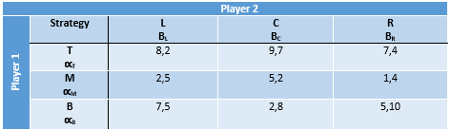
  + σ = (∝T, ∝M, ∝B; βL, βC, βR) = (½ , ¼ , ¼ ; ⅔ , ⅓ , 0)
  + u1(T; R) = u1 (1, 0, 0; 0, 0, 1) = 7
  + u2(T; R) = u2 (1, 0, 0; 0, 0, 1) = 4
* Expected Payoff Example: in the game above, suppose that player 1 believes that player 2 will employ the strategy σ2a = (βL, βC, βR) = (⅔ , ⅓ , 0). Use σ = u1(σi; *θ=*i)
  + u1(1, 0, 0; σ2a) = u1(T; σ2a) = ¾(8)+ ¼(9) + (7)(0) = 8 ⅓
  + u1(0, 1, 0; σ2a) = u1(M; σ2a) = ¾(2)+ ¼(5)+ (1)(0) = 3
  + u1(0, 0, 1; σ2a) = u1(B; σ2a) = ¾(7)+ ¼(2)+ (5)(0) = 5 ⅓
  + u1(½ , ¼ , ¼ ; σ2a) = ½ u1(T; σ2a) + ½ u1(M; σ2a) + ¼ u1(B; σ2a) = ½ (8 ⅓) + ¼ (3) + ¼ (5 ⅓) = 6.25

# Dominant Strategy

* Strictly Dominated Strategy(SD): a pure strategy sia of player i is strictly dominated by strategy σi if, for any s-i, Ui(σi; s-i) > Ui(sia; s-i)
  + If, regardless of what the other person does, I always strictly prefer action A to action B, then action B is strictly dominated by action A
  + Sigma: indicates that, whilst a mixed strategy can dominate a pure strategy, a mixed strategy cannot be dominated
  + s-i: indicates that every possible action taken by every other player must be checked against the mixed strategy σi
  + Example: Prisoner’s Dilemma
    - 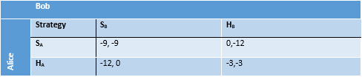
    - If Bob snitches; then Alice prefers SA to HA and if Bob holds; then Alice prefers SA to HA. Therefore, regardless of strategy choice by Bob, Alice prefers SA to HA. *In other words, HA is strictly dominated by SA*
    - Similarly, Bob has the exact same payoffs as Alice and HB is S.D. by SB
* Strictly Dominant Strategy(SD): a strategy sia is a strictly dominant strategy if for any σi ≠ sia and for any s-i Є S-i: Ui(sia; s-i) > Ui(σi; s-i)
* Function of Dominant Strategy Analysis: simplifies games to indicate what we might expect will be played
  + Iterated Eliminations of Strictly Dominated Strategies (IESDS): if strategy Sia is strictly dominated by strategy σi, then we can remove strategy Sia from the strategy space of player i without the game changing
  + A process of elimination can be used, where 1 eliminated strategy will allow you to then eliminate another strategy that you would not have been able to do otherwise
  + Example: prisoner’s dilemma
    - 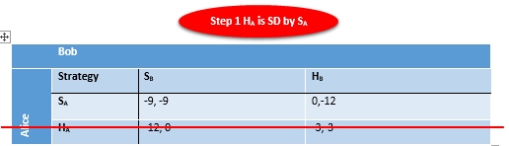
    - 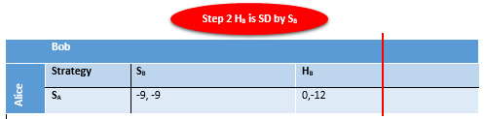
    - 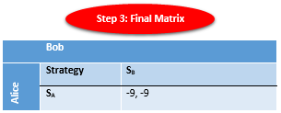
    - Therefore, in the prisoner’s dilemma game we can guarantee both players will snitch. However, despite this, had both held there would have been a more efficient outcome for both players (-3, -3)
  + Example: comparing only two of three strategies of a player can indicate dominant strategies
    - 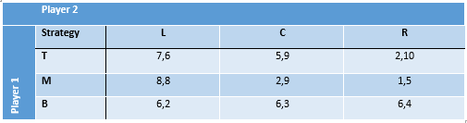
    - 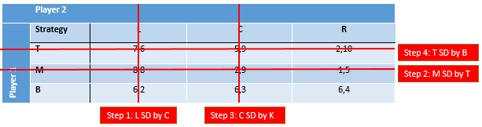
  + Example: a strategy can be strictly dominated by a mixed strategy
    - Step 1: First consider the strategies σ1a = (∝T, ∝M, ∝B) = (½ , ½ , 0) compared with B
      * U1(σ1a; L) = 5 > 3 = U1(B; L)
      * U1(σ1a; C) = 5 > 3 = U1(B; C)
      * U1(σ1a; R) = 4 > 3 = U1(B; R)
    - Step 2: Regardless of strategy choice by player 2, player 1 prefers σ1a over B
    - Step 3: Similarly player 2 will prefer σ2a = (βL, βC, βR) = (½, ½, 0) over R
    - Final: This leaves us with the rationalisable set: S = [(M; L), (M; C), (T; L); (T; C)
      * Rationalizable Set(S1R or R): the set of strategies that remain after using IESDS
    - 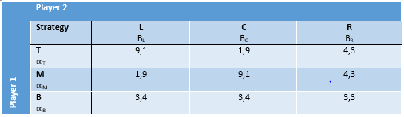
    - 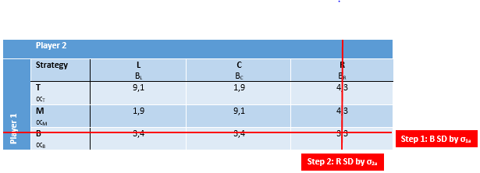
* More Efficient: strategy σa is more efficient than strategy σb if for each player i Ui(σa) ≥ Ui (σb) and for at least one player Ui (σa) > Ui (σb)
* Pareto Efficient: strategy σa is pareto efficient if for any possible strategy σ, σa is more efficient than σ
* Weakly Dominated: a pure strategy si of player i is weakly dominated by strategy σi∊ΔSi if Ui(σi; si) ≥ Ui(si; s-i) for any strategy s-i
  + In other words, sia performs at least as well as does strategy sib, and it performs strictly better against at least one way in which the other players may play the game
  + Example: golden balls - draw the game played in the video using A as the reward and explain why the game is not the same as the prisoner’s dilemma
    - 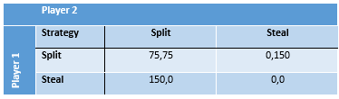
    - In this game steal is a weakly dominant strategy but is not strictly dominant
  + Cannot use IESDS for weakly dominated strategies

# Best Response

* Best Response: if player i has belief *θ*i ∈ ∆Si then strategy σi ∈ ∆Siis best response if Ui( σi; *θ*i ) ≥ Ui( σ-i; *θ*i ) for any σ-i ∈ ∆Si- denoted by BRi(*θ*i ) = σi
  + Example: best response analysis
    - 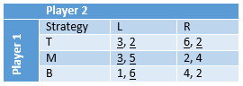
    - Step 1: Find BR1(R) = T
    - Step 2: Find BR1(L) = BR1((1, 0)) = BR1((βL, βR)) = σa = (∝Ta, ∝Ma, ∝Ba) = (∝Ta, 1 - ∝Ta, 0)
    - Step 3: Find BR2(T) = (βLa, 1 - βLa)
    - Step 4: Find BR2(M)= L
    - Step 5: Find BR2(B) = C
    - Step 6: Underline the best responses
  + Battle of the Sexes Example: a man and a woman are dating, the man (M) wants to go to the football game and the woman (W) wants to go to the opera. They are unhappy if they end up at different locations, but are less happy at their less preferred location
    - 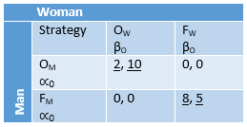
    - Question 1: find the best responses to pure strategies
      * BRM(Ow) = OM
      * BRM(FW) = FM
      * BRW(OM) = OW
      * BRW(FM) = FW
    - Question 2: find the best response to mixed strategies
      * BRM(½, ½) = FM
      * BRM(⅘, ⅕) = (∝Oa, 1 - ∝Oa)
      * BRW(⅓, ⅔) = (βOa, 1 - βOa)
        + If the woman is indifferent between playing OW & FW then:

UW(O; (∝Oa, 1 - ∝Oa)) = UW(FW; (∝Oa, 1 - ∝Oa))

(10)∝Oa + 0(1 - ∝Oa) = (0)∝Oa + 5(1 - ∝Oa)

10∝Oa = 5 - 5∝Oa

15∝Oa = 5

∝Oa = 5/15 = ⅓

* + - * + The above process provides the results of BRW(⅓, ⅔) being equal to (βOa, 1 - βOa)
    - Question 3: find the probability that strategyOM will be played given the probability that OW is played
      * ∝Oa = BRM(βOa)
        + [∝Oa = 1 βO> ⅘ ]
        + [∝Oa∈[0, 1] βO = ⅘ ]
        + [∝Oa = 0 βO < ⅘ ]
    - Question 4: find the probability that βOa will be played given the probability that ∝O is played using the point where the women is indifferent as the interval between [0, 1]
      * βOa = BRW(∝Oa)
        + [βOa = 1 ∝O>⅓ ]
        + [βOa∈[0, 1] ∝O= ⅓ ]
        + [βOa = 0 ∝O < ⅓]
    - Question 5: draw the best response
      * 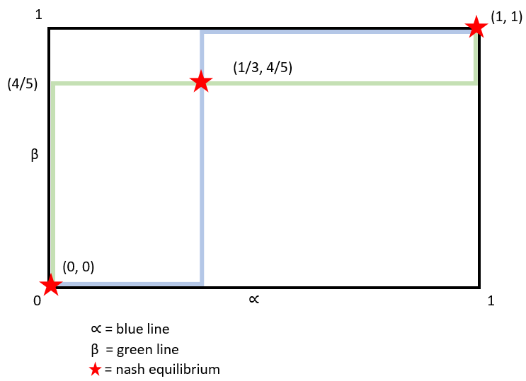
* Underline Trick: where the best responses in a matrix cell are underlined
  + If a payoff is underlined, the strategy cannot be strictly dominated
* Terminology and Notation
  + BRj(*θ*i ) = the best response to belief *θ*i  of player j

# 

# Nash Equilibrium

* Nash Equilibrium (NE): a strategy profile σ∈∆S is a nash equilibrium if σi∈BRi(σ-i) for all players i
  + σi∈BRi(σ-i) is the intersection at the best response function, where both players points of indifference intersect, and one player can not gain by changing strategies
* Pure Strategy Nash Equilibria (PSNE): if all payoffs are underlined in a cell then it is a pure strategy nash equilibria (PSNE)
  + Example: find the PSNE for the *Golden Balls* Game
    - 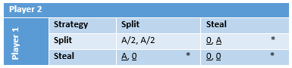
    - PSNE= [(St1; Sp2), (St1; St2), (Sp1; St2)]
      * Notice that nash equilibrium are defined by strategies and not payoffs
  + Example: consider the two person version of the game played in the bar room scene of a beautiful mind. Let *a* represent the small prize and *A* represent the big prize. Draw the game and find all pure strategy nash equilibria
    - 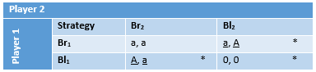
    - NE = [(Bl1; Br2), (Br1; Bl2)]
* Mixed Strategy Nash Equilibrium (MSNE): check the beliefs that make 2(or more) strategies have the same payoff
  + Example: find the MSNE in the previous beautiful mind game. Suppose player 1 plays Bl1 with probability ∝ and player 2 plays Bl2 with probability β
  + 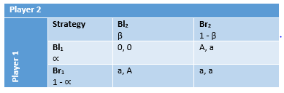
    - Step 1: find belief βa such that U1(Bl1; βa) = U1(Br1; βa)
      * A(1 - βa) = a
      * ∴ βa = (A - a)/A This is the MSNE
    - Step 2: find belief ∝a such that U2(∝a; Bl2) = U2(∝a; Br2)
      * ∝a = (A - a)/A This is the MSNE
    - Step 3: find the expected payoffs for the MSNE if A = $10 and a = $3
      * βa = (A - a)/A = (10-3)/10 = 7/10 & ∝a = 7/10
      * U1(∝a; βa) = U2((∝a; βa)
        + 0(∝a)(βa) + 3(1 - ∝a)(βa) + 10(∝a)(1 - βa) + 3(1 - ∝a)(1 - βa) = 0(7/10)(7/10) + 3(3/10)(7/10) + 10(7/10)(3/10) + 3(3/10)(3/10) = 3
      * Alternatively: U1(BR1; βa) = 3(7/10) + 3(3/10) = 3
* MSNE Discovery Process
  + Step 1: find the set of rationalizable strategies using IESDS
  + Step 2: for each player, find all expected utilities for each pure rationalizable strategy
  + Step 3: for each player, compare all two strategy combinations to find the point of indifference between strategies
    - This is where the player i’s belief about player x makes them indifferent between two strategy moves
    - The point of difference between the two strategies must be the best response
  + Step 4: from this, write the points of indifference for the NE
    - Eliminate strategy combinations where the indifference point is not the best response
    - The NE is found by combining all the points of indifference between players
      * Wherein both players are playing their best response
  + Example: find all NE in the following game
    - 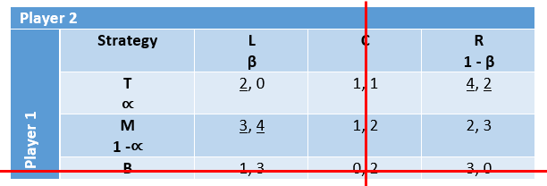
    - Step 1: find the set of rationalizable strategies using IESDS
      * R = [(T; L), (T; R), (M; C), (M; R)]
    - Step 2: for each player, find all expected utilities for each pure rationalizable strategy
      * Player 1:
        + U1(T; β) = 2(β) + 4(1 - β) = 4 - 2β
        + U1(M; β) = 3(β) + 2(1 - β) = 2 + β
      * Player 2:
        + U2(∝; L) = 0(∝) + 4(1 - ∝) = 4 - 4∝
        + U2(∝; R) = 2(∝) + 3(1 - ∝) = -1∝ + 3
    - Step 3: for each player, compare all two strategy combinations to find the point of indifference between strategies
      * Player 1: U1(T; β) = U1(M; β)
        + ∴ 4 - 2β = 2 + β
        + ∴ β = ⅔
      * Player 2: U2(∝; L) = U2(∝; R)
        + ∴ 4 - 4∝ = 3 - ∝
        + ∴ ∝ = ⅓
    - Step 4: from this, write the points of indifference for the NE
      * NE = (∝T, ∝M, ∝B; βL, βC, βR) = [(0, 1, 0; 1, 0, 0), (1, 0, 0; 0, 0, 1), (⅓, ⅔, 0; ⅔, 0, ⅓)]
        + This can be used to graph the best response functions with β in relation to ⅔ and ∝ in relation to ⅓
  + Example: find all NE in the following game, skipping steps 1 and 2
    - 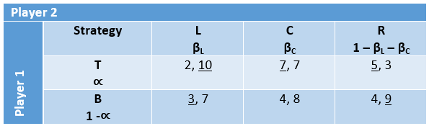
    - Step 3: for both players
      * Player 1
        + U1(T; βL, βc) = U1(B; βL, βC)

∴ 2βL + 7βC + 5(1 - βL - βC) = 3βL + 4βC + 4(1 - βL - βC)

∴2βL = 1 + 2βC

∴βL = ½ + βC

* + - * Player 2
        + U2(∝; L) = U2(∝; C) > U2(∝; R)

∴ 10∝ + 7(1 - ∝) = ∝ + 8(1 - ∝)

∴ ∝ = ¼

∴ U2(¼; L) = U2(¼; C) = 7.75 > U2(¼; R) = 7.5

* + - * + U2(∝; L) = U2(∝; R) >U2(∝; C)

∴ 10∝ + 7(1 - ∝) = 3∝ + 9(1 - ∝)

∴ ∝ = 2/9

∴ U2(2/9; L) = U2(2/9; R) = 7.76 < U2(2/9; C) = 7.77

This mixed strategy will never be utilized as U2(∝; C) is greater than the mixed strategy

* + - * + U2(∝; R) = U2(∝; C) >U2(∝; L)

∴ 3∝ + 9(1 - ∝) = 10∝ + 7(1 - ∝)

∴ ∝ = 1/5

∴ U2(⅕; C) = U2(⅕; R) = 7.8 > U2(∝; L) = 7.6

This mixed strategy will never be utilized as from the conditions for player 1 we already know that βL>½

* + - Step 4: NE = (¼, ¾; ¾, ¼, 0)
      * Note: (βL, βC, 1 - βL - βC) = (¾, ¼, 0) as R is not a strategy choice in this MSNE
* Terminology and Notation
  + ㅠ = the payoff profile for a pure strategy nash equilibria
    - Example: ㅠ = [(π11; π21); (π12; π22)] = [(a; A), (A; a)]
  + πii = the payoff of a single strategy in a pure strategy nash equilibria
    - Example: π11 = U1(Br1;Bl2)
* Nash’s Theorem: every finite game has at least 1 equilibrium

# Bertrand Model

* The Bertrand Model: there are two firms facing inverse demand *p = a - Q = (a - bq1 - bq2)* and a cost of C(qi) = Cqi + F. The firms simultaneously choose prices p1 & p2. The firms will always undercut each other unless ㅠ<0 (when F = 0)
  + Step 1 - Find Demand:
    - If p1<p2: everybody buys from Firm1
      * q1 = (1/b)(a - p1)
      * q2 = 0
    - If p1>p2: everybody buys from Firm2
      * q1 = 0
      * q2 = (1/b)(a - p2)
    - If p1=p2: demand is split
      * q1 = (1/(2b))(a - p1)
      * q2 = (1/(2b))(a - p2)
    - q1 =
      * [if p1< p2 1/b(a-p1) ]
      * [if p1= p2 (1/(2b))(a - p1) ]
      * [if p1< p2 0 ]
    - q2 =
      * [if p2< p1 1/b(a-p2) ]
      * [if p2= p1 (1/(2b))(a - p2) ]
      * [if p2< p1 0 ]
  + Step 2 - Find Profit:
    - ㅠ1 = TR - TC = q1p1 - C(q1) =
      * [if p1< p2 1/b(a-p1)p1 - C(1/b(a-p1) ]
      * [if p1= p2 (1/(2b))(a - p1)p1 - C((1/(2b))(a-p1)) ]
      * [if p1< p2 0 - F ]
    - ㅠ2 = TR - TC = q2p2 - C(q2) =
      * [if p2< p1 1/b(a-p2)p2 - C(1/b(a-p2) ]
      * [if p2= p1 (1/(2b))(a - p2)p2 - C((1/(2b))(a-p2)) ]
      * [if p2< p1 0 - F ]
  + Step 3 - Find Nash Equilibrium: where profit is maximized
    - If p1< C & F = 0, then the profit is negative (ㅠ<0). Therefore, the nash equilibrium will be: (p1a; p2a) = C
      * Conclusion: the firms set price equal to marginal cost. This is perfect competition

# The Ultimatum Game

* The Ultimatum Game: player 1 is endowed with $10, player 1 decides how to split the money between herself and player 2. After seeing the proposed split, player 2 may either accept or reject the proposal. If the proposal is accepted it goes through and if it is rejected both players get zero dollars
  + Draw Extensive Form: for continuous and discrete numbers
    - 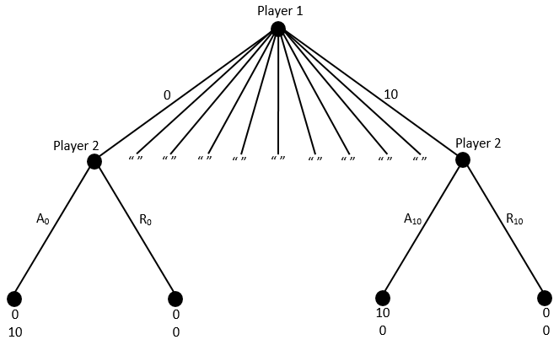
    - 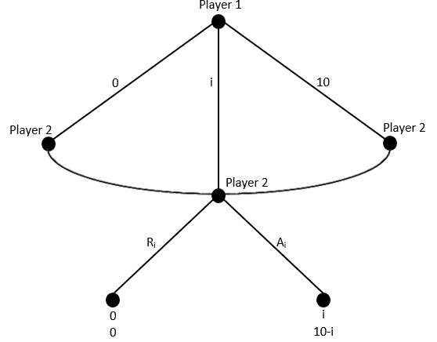
  + Find PNSE: when player 1 actually gets to split $3 and can only propose whole number splits
    - 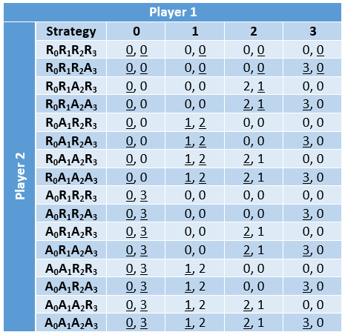
    - There are 17 PSNEs in this game

# Sequential Rationality and Subgame Perfection

* Sequential Rationality: player i’s strategy needs to specify an optimal action for each of player i’s information sets, even if player i does not believe(ex ante) that the information set will be reached
* Subgame: a node in the tree is said to initiate a subgame if none of its successors are in an information set that contains nodes that are not successors of it. A subgame is the tree structure defined by this node and its successors
  + Logic: x is a node. If there is a node y that is not a successor of x but is connected to x or one of its successors by a dashed line, then x does not initiate a subgame
    - Subgames are self-contained extensive forms—meaningful trees on their own
  + Proper Subgame: subgames that start from nodes other than the initial node
  + Example: X is a subgame, Y is not
    - 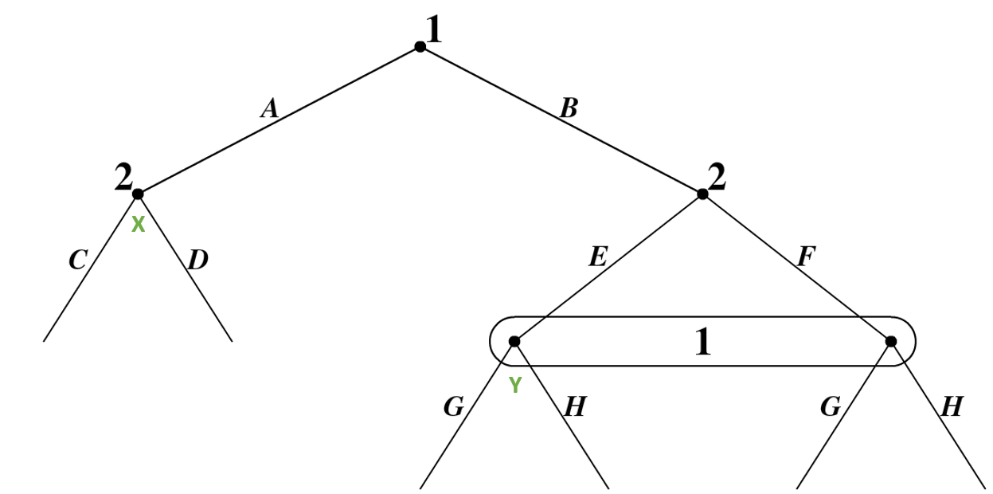
* Subgame Perfect Nash Equilibria(SPNE): a nash equilibrium is subgame perfect if it is an equilibrium at every subgame/information set
* Backward Induction - Finding SPNE: on the game tree, go to a terminal information set and decide which strategy or strategies earn the highest payoff for that player’s information set. Then transfer the payoffs to the terminal node as if no decision is made at this node, repeat this process
  + Bold/Green Lines: indicate optimal strategies
  + Terminal Information Set: terminal Information sets exist when all decisions lead to a terminal node
  + Continuation Payoff: the expected payoff at each information set given backward induction
    - When solving optimums using backward induction, payoffs move up the information sets in the game tree
  + Example - The Ultimatum Game: suppose the proposer splits $3 using only whole numbered splits. Further suppose that I believe that if a player is indifferent between two or more strategies they will play all strategies with equal probability. Find the SPNE of this game
    - 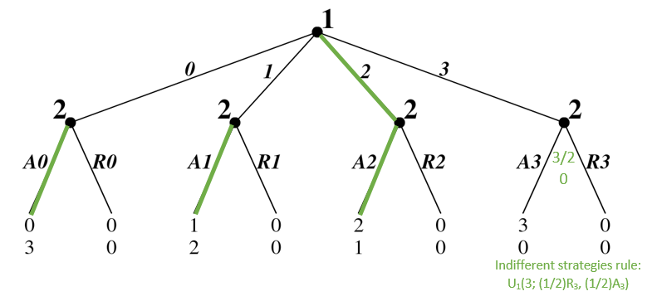
    - SPNE = (2; A0, A1, A2, (1/2)R3, (1/2)A3)
  + Example: Big Game
  + 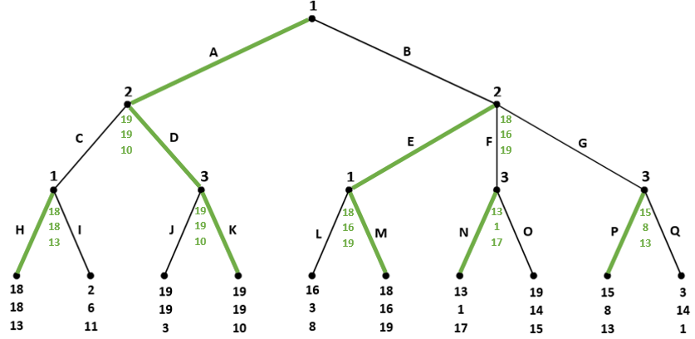
    - Conclusion: every finite game with perfect information, has a subgame perfect NE in pure strategies

# Conditional Dominance

* Conditionally Dominated: let H be the set of information sets and Hi the set of information sets for player i. S = S1 x S2 x … x Sn is the strategy space. Player i’s strategy is conditionally dominated if there is an information set HЄHi such that si is dominated in X∩S(h)
  + Iterated Conditional Dominance: if si is conditionally dominated, then it is dominated in every subgame. This can be realised by forward induction of matrix transformation
    - Forward Induction: going from the top to the bottom of the game tree and analysing whether a particular branch would ever be reasonably chosen(if not, then it is dominated)
    - Matrix Transformation: where there are information sets combined into sets/dashed lines, a matrix can be used to find conditionally dominated strategies
      * Step 1: for dashed information sets, create a subgame matrix
      * Step 2: find dominated strategies and best responses
      * Step 3: cross out tree branch with no best responses or that is dominated to find optimal strategies and proceed with continuation payoffs
    - Intuition: a lot of conditional dominance is based on using intuition for discovery
  + Example: battle of the sexes with a twist - the couple fits perfect stereotypical gender roles and is stupid because they do not communicate. However, before the couple leaves work, if the woman texts the man, they will go home and watch netflix
    - Draw in Extensive Form
      * 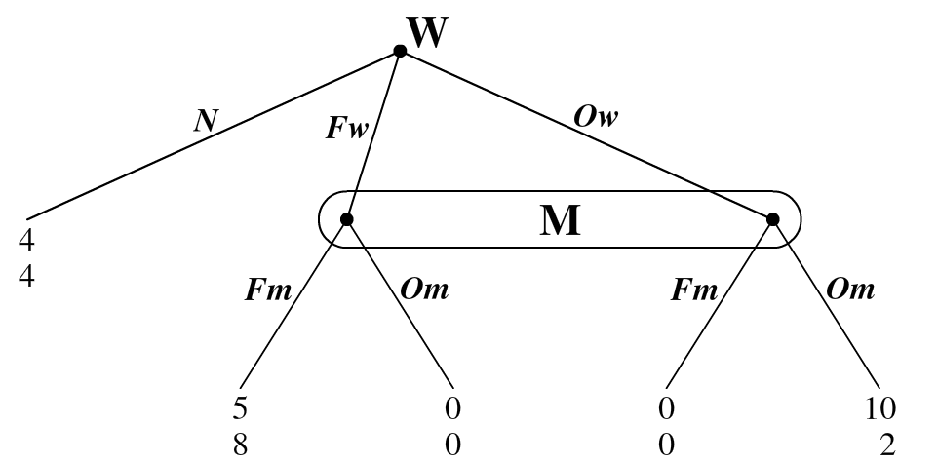
    - Transform Combining Matrices and Trees
      * 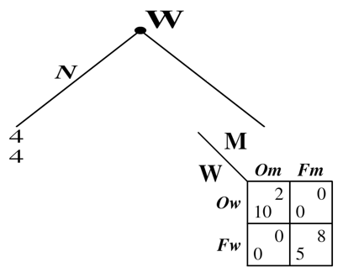
      * Find SPNE: [(Ow; Om), (Fw; Fm), (N; ⅔(Fm), ½(Om))]
    - Condition (N = 6): if the man receives the text he knows that the woman will earn 6. If the man doesn’t receive the text, then he knows that the woman will only go to the opera (because this is the only way she can earn more than 6). Since the woman is going to the opera, the man prefers to go to the opera. Therefore, the woman prefers SPNE (Om; Om)
      * 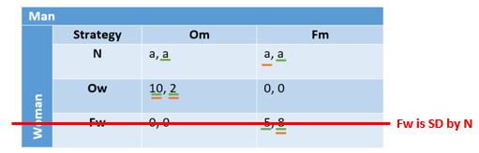
        + If these ‘a’s are 4 then see green underline, if these ‘a’s are 6 then see orange underline
      * 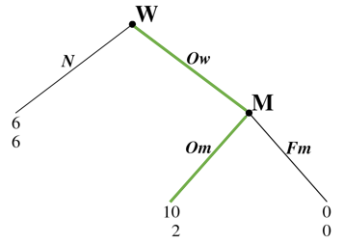
      * Find SPNE: [(Ow; Om)]
  + Example - Conditional Dominance for Equal Payoffs: let β equal the probability that player 2 plays c. Let ∝ = the probability that player 1 plays a
    - 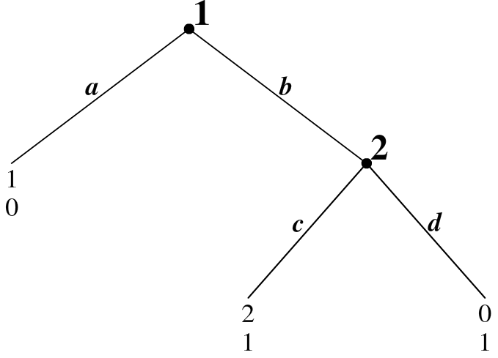
    - Find the Different Payoff Functions for Player 1
      * U1(a; (1-β)d) = 1
      * U1(b; (1-β)d) = 2β + 0 (1-β) = 2β
    - Find Cases where the Payoff Functions are =, <, or >
      * Case 1: U1(a; (1-β)d) > U1(b; (1-β)d)
        + ∴ 1 > 2β
        + ∴ β < 1/2
        + ∴ the SPNE is (a; (1-β)d)
      * Case 2: U1(a; (1-β)d) < U1(b; (1-β)d)
        + ∴ β > 1/2
        + ∴ the SPNE is (b; (1-β)d)
      * Case 2: U1(a; (1-β)d) = U1(b; (1-β)d)
        + ∴ β = 1/2
        + ∴ the SPNE is (∝a + (1-∝)b; βc + (1-β)d)

# Cournot, Monopoly and Stackelberg Model

* The Cournot Model (1836): there are n firms in an industry. Each firm faces the inverse demand function *p = a - bQ*, where: *QTotal = q1 + … + qn = ∑qi*. Each firm faces a cost function of *Ci(qi) = Ciqi + F*, where F is the fixed cost. The firm will simultaneously choose quantity qi. The goal of each firm is profit maximization
  + Cournot Model Graphic Representation:
    - 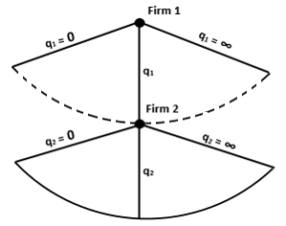
  + Solution Steps: for finding nash equilibrium
    - Step 1: set up profit function for all firms where ㅠi = P*qi - Ci(qi)
    - Step 2: take FOC to find where profit is maximized for all firms
    - Step 3: use this to find q1 = BR1(q2) where q2 = 0 and q2>0
      * This is where profit is maximized
    - Step 4: graph BR function to find NE
    - Step 5: find equilibrium quantities by substituting q1 and vice versa into q2  to find q1* and q2*
    - Step 6: find the nash equilibrium payoffs by computing P*, ㅠ1* and ㅠ2*
  + Example: The Cournot Duopoly n = 2; a = 100; b = 1; C1 = C2 = 10; F = 0
    - Step 1: set up profit function for all firms where ㅠi = P*qi - Ci(qi)
      * ㅠ = TR - TC = PQ - TC
      * ㅠ1 = (a - b(q1+ q2))q1 - C1q1 - F = (100 - q1 - q2)q1 - 10q1
      * ㅠ2 = (a - b(q1+ q2))q2 - C2q2 - F = (100 - q1 - q2)q2 - 10q2
    - Step 2: take FOC to find where profit is maximized for all firms
      * ∂ㅠ1/∂q1 = 0
      * ∴ 0 = 90 - 2q1 - q2
      * ∴ q1 = 45 - 0.5q2
      * ∴ q2 = 45 - 0.5q1
    - Step 3: use this to find q1 = BR1(q2) where qi = 0 and qi>0
      * q1 = BR1(q2) =
        + [45 - 0.5q2, q2 ≤ 90]
        + [0, q2 > 90]
      * q2 = BR1(q1) =
        + [45 - 0.5q1, q1 ≤ 90]
        + [0, q1 > 90]
    - Step 4: graph BR function to find NE:
      * 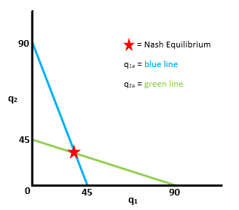
    - Step 5: find equilibrium quantities by substituting q1 and vice versa into q2  to find q1* and q2*
      * q2 = 45 - 0.5(45 - 0.5q2) = 22.5 + 0.25q2
        + ∴ 0.75q2 = 22.5
        + ∴ q2 = 22.5*(4/3) = 30
        + ∴ q1 = 30
      * Result: the NE is (q1a; q2a) = (30; 30)
    - Step 6: find the nash equilibrium payoffs by computing P*, ㅠ1* and ㅠ2*
      * ㅠ1 = ㅠ2 = (100 - q1 - q2)q1 - 10q1 = (100 - 30 -30)30 - 10(30) = 40*30 - 300 = 900
* Cournot, Monopoly, and Stackelberg Example: suppose inverse market demand is P = 100 - 2Q; Q = q1 + q2; Ci(qi) = 20qi. Suppose the firms are cournot quantity competitors.
  + Cournot: find the cournot nash equilibrium
    - Step 1: set up profit function for all firms where ㅠi = P*qi - Ci(qi)
      * ㅠ1 = P*q1 - C1(q1) = (100 - 2(q1 + q2))q1 - 20q1
      * ㅠ2 = P*q2 - C2(q2) = (100 - 2(q1 + q2))q2 - 20q2
    - Step 2: take FOC to find where profit is maximized for all firms
      * ∂ㅠ1/∂q1 = 0
      * ∴ 0 = 80 - 4q1 - 2q2
      * ∴ q1 = 20 - (1/2)q2
      * ∴ q2 = 20 - (1/2)q1
    - Step 3: use this to find q1 = BR1(q2) where qi = 0 and qi>0
      * q1 = BR1(q2) =
        + [ 20 - (1/2)q2, q2 ≤ 40]
        + [0, q2 > 40]
      * q2 = BR1(q1) =
        + [ 20 - (1/2)q1, q1 ≤ 40]
        + [0, q1 > 40]
    - Step 4: graph BR function to find NE
      * 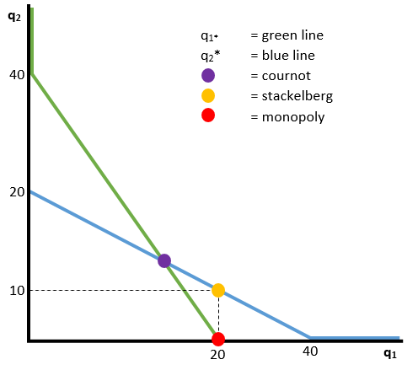
    - Step 5: find nash equilibrium quantities by substituting q1 into q2  to find q1* and q2*
      * q1 = 20 - (1/2)q2 = 20 - (1/2)(20 - (1/2)q1) = 10 + (1/4)q1
      * ∴ q1* = 40/3
      * ∴ q2* = 40/3
    - Step 6: find the nash equilibrium payoffs by computing P*, ㅠ1* and ㅠ2*
      * P* = 100 - 2(40/3 + 40/3) = 300/3 - 160/3 = 140/3
      * ㅠ1* = ㅠ2* = (P*)*(q*) - 20q* = (P* - 20)q* = (140/3 - 60/3)*(40/3) = 3200/9
  + Monopoly: now suppose that everything in the previous example stays the same except firm 2 does not exist. Find P*, Q*, and ㅠ*
    - We can utilise what we’ve done already by taking q1 = BR1(q2 = 0) = 20
      * q1* = 20 P* = 60
      * ㅠ* = (P* - 20)Q* = (60 - 20)*20 = 800
  + Stackelberg: suppose we have 2 firms and everything from Cournot remains exactly the same except when firm 1 moves, firm 2 is able to view firm 1’s choice as the first mover
    - Stackelberg Extensive Form Representation:
      * 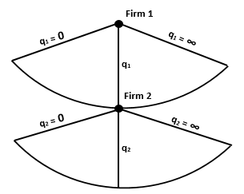
    - Step 1: find firm 1’s profit as a function of q1 with q2 solved for q1 (this is the best response)
      * Firm 2’s BR is q2 = 20 - (1/2)q1
      * ㅠ1 = (80 - 2q1 - 2q2)q1 = (80 - 2q1 - 2(20 - (1/2)q1))q1 = (40 - q1)q1 = 40q1 - q12
    - Step 2: take FOC for q1’s profit to find where profit is maximized
      * ∂ㅠ1/∂q1 = 40 - 2q1 = 0
      * ∴ q1* = 20
    - Step 3: using the equation for q2; P; and ㅠ; plug in results to find q2*, P*, ㅠ1* and ㅠ2*
      * ∴ q2* = 10
      * ∴ P* = 40
      * ∴ ㅠ1* = (P* - 20)q1* = 400
      * ∴ ㅠ2* = (P* - 20)q2* = 200
  + Total Results
    - ㅠM* = ㅠ1*Monopoly = 800
    - ㅠC* = ㅠ1*Cournot = ㅠ2* Cournot = 3200/9
    - ㅠS1* = ㅠ1*Stackelberg = 400
    - ㅠS2* = ㅠ2*Stackelberg = 200
    - ∴ ㅠM* > ㅠS1* > ㅠC* > ㅠS2*
* Calculating Stackelberg vs Cournot: substitute BR2 into ㅠ1 vs substitute BRi into BRi

# Industrial Organisation: Capacity Limits

* Capacity Limit: when, for various reasons, the firm is unable to sell the amount of product that they would like to
* Example: suppose that two firms are in standard cournot competition where: P = 10000 - 2Q; Q = q1 + q2, Ci(qi) = 4000qi. Before the firms choose quantity, they must first choose firm size with fixed costs. The possible firm sizes are: the high capacity firm, which has no capacity limit but costs 2000000, the low capacity firm, which has a capacity of 250 units but costs 750000, or the firm can choose to opt out, incurring 0 fixed costs
  + Step 1: draw the game tree

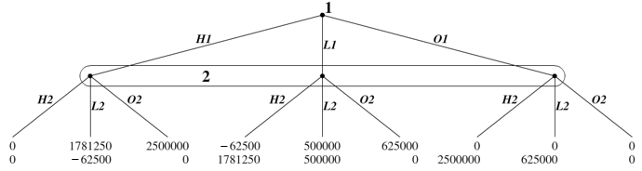

* + Step 2: solve for equilibrium quantities given each possible firm sizes and insert into game tree
    - Case 1: (O1; O2)
      * ∴ㅠ1 = ㅠ2 = 0
    - Case 2: (O1; L2)
      * ∴ㅠ1 = 0
      * ∴ㅠ2 = (10000 - (2*250))250 - 4000*250 - 750000 = 625000
    - Case 3: O1; H2
      * ∴ㅠ1 = 0
      * ㅠ2 = (10000 - 2q2)q2 - 4000q2 - 2000000
        + 0 = ∂ㅠ2/∂q2 = 6000 - 4q2
        + q2* = 1500
        + P* = 7000

∴ㅠ2 = (7000*1500) - 2000000 = 2500000

* + - Case 4: (L1; L2)
      * q1 = q2 = 250
      * P = 10000 - 2(250 + 250) = 9000
      * ∴ㅠ1 = ㅠ2 = (9000 - 4000)(250) - 750000 = 500000
    - Case 5: (L1; H2)
      * q1* = 250
      * ㅠ2 = (10000 - 4000 - (2*250) - 2q2)q2 - 2000000
        + ∂ㅠ2/∂q2 = 0
        + 0 = 5500 - 4q2
        + q2* = 1375
        + P* = 10000 - 2(1375 + 250) = 6750

∴ㅠ2 = (6750 - 4000)1375 - 2000000 = 1781250

∴ㅠ1 = (6750 - 4000)250 - 750000 = -62500

* + - Case 6: (H1; H2)
      * ㅠ1 = (6000 - 2q1 - 2q2)q1 - 2000000
        + 0 = ∂ㅠ1/∂q1 = 6000 - 4q1 - 2q2 = 6000 - 6q

Since in equilibrium q1 = q2 = q, we’ll just plug that in

* + - * + 0 = 6000 - 4q - 2q
        + q* = 1000
        + P* = 6000
        + ∴ ㅠ1 = ㅠ2 = (6000 - 4000)1000 - 2000000 = 0
  + Step 3: use step 2 to find subgame perfect firm sizes
    - 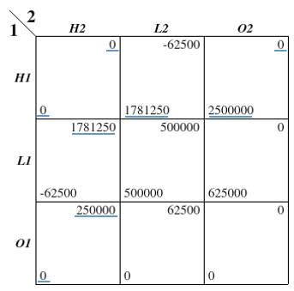
    - Solving for the MSNE: [(H1; H2), (O1; H2), (H1; O2)]
      * Conclusion: at these quantities one firm limits the capaciy of the other
    - Solving for SPNE
      * In total there are 20 information sets as the payoffs in the game tree are just the continuation payoffs for the following tree branch concerning quantities
        + 
      * Therefore, the SPNE includes 10 strategy moves for each player
        + SPNE = ( _, _, _, _, _, _, _, _, _, _; _, _, _, _, _, _, _, _, _, _)
* Example Based on Prior Example: now assume everything about the previous game remains the same excepts for 2 things. First, player 1 makes her decision on firm size prior to player 2. Player 2 can perfectly observe the decision before making his. Second the cost of having a high capacity firm is now 2100000. Draw Game Tree
  + 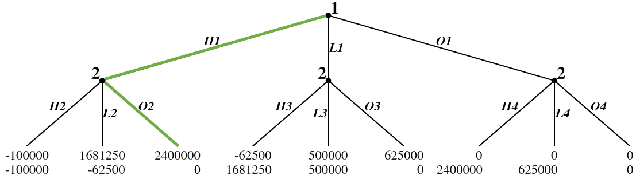
  + Find Firm 1’s Optimal Decision at Starting Node: H1
  + Find Firm 2’s Best Response to Firm 1: O2
  + Conclusion: limit quantity can be used by existing firms in an attempt to convince competitors to stay out of the market - this is an antitrust decision where less quantity is produced and a monopoly occurs

# Finitely Repeated Games

* SPNE: in finitely repeated games the SPNE is just any sequence of stage MSNE
  + Stage MSNE: the MSNE that occur in each stage of a repeated game
* Total Payoff: the total payoff is easy to calculate from average payoff where the total payoff is the sum of average payoffs
* Repeated Game Example: show the prisoner’s dilemma as a twice repeated game where the payoffs are the average
  + 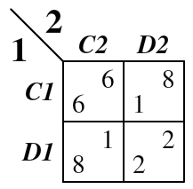
  + Repeated Game - Matrix Form
    - 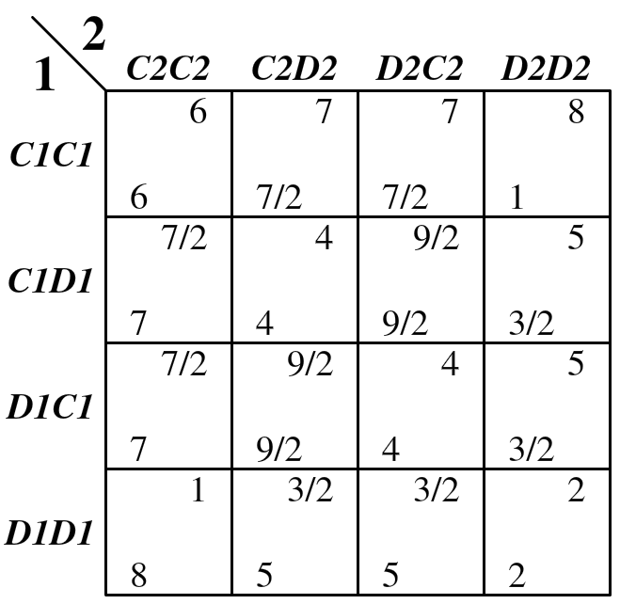
    - All possible SPNE in finitely repeated games can be represented by a sequence of stage NE, with payoffs equal to averages
      * SPNE Using Underline Trick: (D1, D1; D2, D2)
* Repeated Game Example: find the SPNE for the two stage repeated battle of the sexes
  + 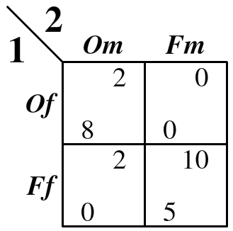
  + Step 1: find the stage equilibria
    - (O; O), (F; F), (M; M)
  + Step 2: find the different SPNE by combining the different equilibria for each stage
    - The number of SPNE is nt where t is the number of periods and n is the number of stage equilibria
    - SPNE = (O, O; O, O), (O, F; O, F), (O, M; O, M), (F, O; F, O), (F, F; F, F), (F, M; F, M), (M, O; M, O), (M, M; M, M), (M, F; M, F)
* Convex Combination of Payoffs: a box that contains all possible payoffs no matter how many times the game is iterated
  + Example: Prisoner’s Dilemma
    - 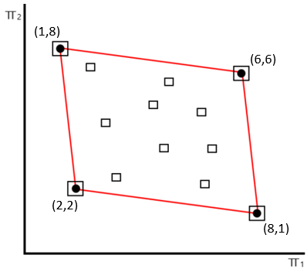

# Infinite Repeated Games

* Payoffs: are calculated using a discounting factor δ that is to the power of the t-1 being discounted
  + Logic: this is as future value is lower than present value, so the future must be discounted
  + Example: suppose that I always cooperate and the other person always defects in the prisoner’s dilemma game, what is my total payoff given discount factor δ
    - ㅠ1 = 1 + 1δ + 1δ2 + 1δ3 + … + 1δt-1  = 1δi
    - δㅠ1 = δ + 1δ2 + 1δ3 + … + 1δt-1
      * ㅠ1 - δㅠ1 = 1
      * ㅠ 1(1 - δ) = 1
      * ㅠ1 = 1/(1-δ)
  + Payoff Formula: ㅠi = 1/(1-δ)
* Possible Payoffs: in infinitely repeated games, all point in the convex combination of payoffs are possible
  + 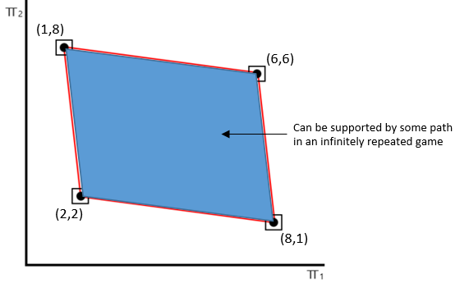
    - This is based on earlier prisoner’s dilemma example
* Trigger Strategy: a strategy that begins in a cooperative state and moves to a punishment state if necessary
  + Analysis Guides
    - One Shot Principle: only 1 deviation in a trigger strategy needs to be used to find payoffs as one deviation will result in the same ઠ as many deviations
      * Example: when defecting, defect once then cooperate to analyze
    - Strategy Assumptions: for trigger analysis, assume both players are using the given strategy and analyze defections (unless stated otherwise), such as cooperative or defecting against grim trigger
  + Grim Trigger: begins by cooperating and continues to cooperate as long as the other person cooperates. As soon as the other person defects, I move to punishment and I stay there forever
    - 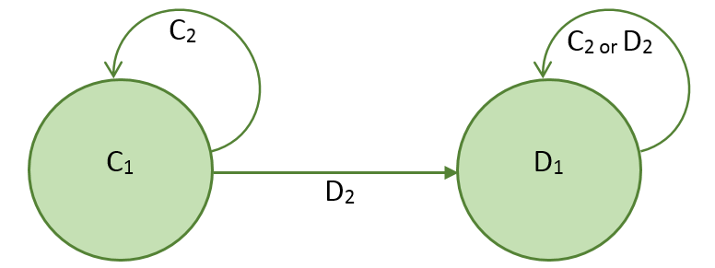
    - Example: if the other person is playing grim trigger, what is my payoff for playing grim trigger?
      * ㅠ1GT = 6 + 6δ + … = 6/(1 - δ)
    - Continuation Example: what is my payoff if I instead decide to defect?
      * ㅠ1D = 8 + 2δ + 2δ2 + … = 6 + [2 + 2δ + 2δ2 + …] = 6 + 2/(1 - δ)
        + ∴ ㅠ1D = [6(1 - δ)]/(1 - δ) + 2/(1 - δ) = (8 - 6δ)/(1 - δ)
    - Continuation Example: when is playing grim trigger better for me than playing defect?
      * ㅠ1GT > ㅠ1D = 6/(1 - δ) > (8 - 6δ)/(1 - δ) = 6 > 8 - 6δ = 6δ > 2
        + ∴ δ > 1/3
  + Tit-for-Tat: begins by cooperating and continues to cooperate as long as the other person cooperates. As soon as the other person defects I move to punishments, I stay in punishment until the other person cooperates and I move back to cooperate
    - 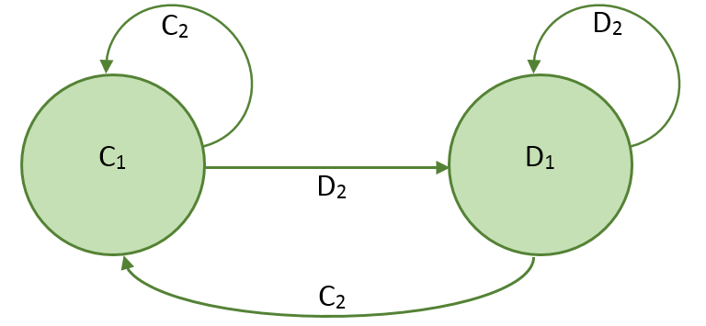
    - Partial Defection: for tit-for-tat you should measure partial defections for infinite games
    - Example: if the other person is playing tit-for-tat, what is my payoff if I defect once?
      * ㅠ1DTFT = 8 + 1δ + 6δ2 + 6δ3 + …
    - Continuation Example: when is playing tit-for-tat better for me than defecting?
      * ㅠ1GT = ㅠ1TFT > ㅠ1DTFT = 6 + 6δ > 8 + 1δ = 5δ > 2
        + ∴ δ > ⅖
* Folk Theorem: any outcome that is supported by a rationalizable strategy can be supported by a subgame perfect nash strategy infinitely repeated
  + Prisoner’s Dilemma Example
    - 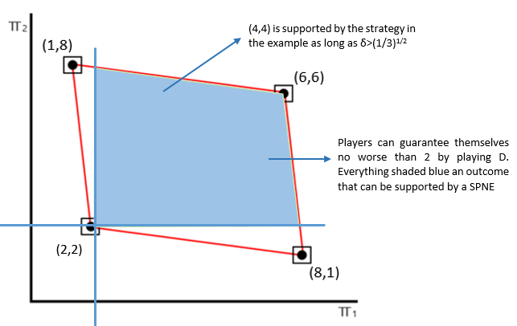
      * 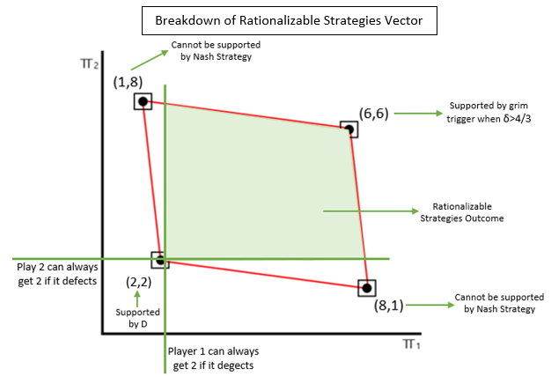
    - Rationalizable Strategies Cases: suppose player 1 has the following strategy, alternate between C and D on odd and even rounds respectively. If player 1 ever sees player 2, play D in 2 consecutive rounds, then grim trigger. What is the payoff for player 2 in each of the following instances:
      * Case 1: always cooperate
        + ㅠC2 = 6 + 1δ + 6δ2 + 1δ3+ ...
      * Case 2: always defect
        + ㅠD2 = 8 + 2δ + 2δ2 + 2δ3 + … = 2/(1 - δ) + 6 = (8 - 6δ)/(1 - δ)
      * Case 3: player 2 mirror’s player 1’s strategy
        + ㅠM2 = 6 + 2δ + 6δ2 + 2δ3 + …

δ2ㅠ = 6δ2 + 2δ3 + …

ㅠ - δ2ㅠ = 6 + 2δ

(1 - δ2) = 6 + 2δ

∴ ㅠM2 = (6 + 2δ)/(1 - δ)2

* + - * Case 4: player 2 mirror’s player 1’s strategy in reverse
        + ㅠR2 = 8 + 1δ + 8δ2 + 1δ3 + …
    - When is mirroring a best response to player 1’s strategy (given that 2 other cases are strictly dominated by case 2 & 3)
      * ㅠM2 > ㅠD2
        + (6 + 2δ)/[(1 + δ)(1 - δ)] > (8 - 6δ)/(1 - δ)
        + (6 + 2δ)/(1 + δ) > 8 - 6δ
        + 6 + 2δ > (8 - 6δ)(1 + δ)
        + 6 + 2δ > 8 + 8δ - 6δ - 6δ2
        + 6 > 8 - 6δ2
        + 6δ2 > 2
        + δ > (⅓)2
      * Conclusion: as long as δ > (⅓)2, mirroring player 1’s strategy is better for player 2 than defecting. The average payoff for each player in this strategy is 4

# Competitive Markets in Repeated Settings

* Time Horizon Model: suppose two firms are in a cournot duopoly where P = 300 - q1 - q2 and Ci(qi) = 0. The two firms may either collude with one another (where each firm produces exactly half of the monopoly output), or they deviate by competing
  + There are therefore three strategy cases that form a matrix
    - Case 1: both firms collude and produce half monopoly output
      * If a monopoly, then ㅠ = (300 - Q)Q = 300Q - Q2
        + 0 = ∂ㅠ2/∂Q = 300 - 2Q
        + ∴ Q = 150
      * Therefore, each firm produces 75
        + q1, = q1 = 75
        + ∴ P = 150
        + ∴ ㅠ1 = ㅠ2 = p*q = 150*75 = 11250
    - Case 2: both firms compete with one another
      * The best response functions for the firms are:
        + q1 = BR1(q2) =

[150 - 0.5q2, q2 ≤ 300]

[0, q2 > 300]

* + - * + q2 = BR2(q1) =

[150 - 0.5q1, q1 ≤ 300]

[0, q1 > 300]

* + - * It is obvious that the solution using cournot is:
        + q2 = q1 = 100
        + ∴ P = 100
        + ∴ ㅠ1 = ㅠ2 = p*q = 150*75 = 10000
    - Case 3: one firm colludes, the other defects
      * Firm 1 is colluding: q1 = 75
      * Firm 2 is defecting: q2 = 150 - 0.5(75) = 112.5
      * ∴ P = 112.5
      * ∴ ㅠ1 = 75*112.5 = 8437.5
      * ∴ ㅠ2 = 112.5*112.5 = 12656.25
    - 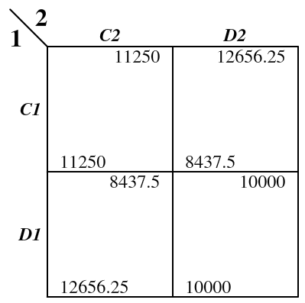
  + What is the SPNE in a finite game: (D1; D2)
  + When is grim trigger SPNE in an infinite game
    - ㅠGT = 11250 + 11250δ + 11250δ2 + …
      * ∴ ㅠGT = 11259/(1 - δ)
    - ㅠD = 12656.25 + 10000δ + 10000δ2 + … = 10/(1 - δ) + 2656.25
      * ∴ ㅠD = (12656.25 - 2656.25δ) /(1 - δ)
    - ㅠGT > ㅠD
      * 11259/(1 - δ) > (12656.25 - 2656.25δ) /(1 - δ)
      * δ > 1406.25/2656.25
      * ∴ δ > 9/17 = 0.53
    - Model Conclusion: I only need to believe that I have a 53% probability of existing next year to want to collude, so long as there is a unknown time horizon
  + When is tit-for-tat a SPNE in an infinite game
    - ㅠTFT = 11250 + 11250δ + ...
    - ㅠD = 12656.25 + 8437.5δ + 11250δ2 + ...
    - ㅠTFT > ㅠD
      * 11250δ + 11250δ > 12656.25 + 8347.5δ
      * δ > 1406.25/2812.5 = ½
  + Interest Rate Relationship: lower real interest rates make the discount factor higher which leads to cartel stability, higher real interest rates make the discount factor lower which leads to cheating. Remember that δ = 1/(1+r)

# Random Events & Incomplete Information

* Example: what is player 2’s payoff from choosing left and right?
  + 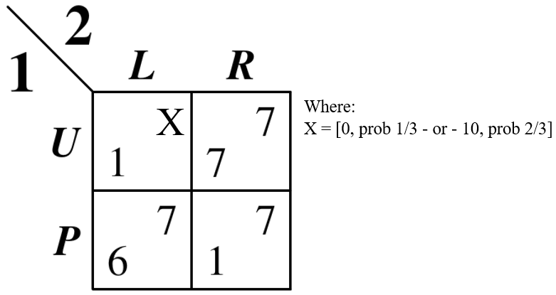
  + U2(∝; L) = ∝X + 7(1 - ∝) = ∝[(0)(⅓) + (10)(⅔)] + 7(1 - ∝) = (20/3)∝ + 7 - 7∝
    - ∴ U2(∝; L) = 7 - ∝/3
  + U2(∝; R) = 7
  + Conclusion: R weakly dominates L. If 10 = 11, than L would weakly dominate R
* Example: find the expected utilities of player 1, given that good weather occurs with 9/10 probability
  + 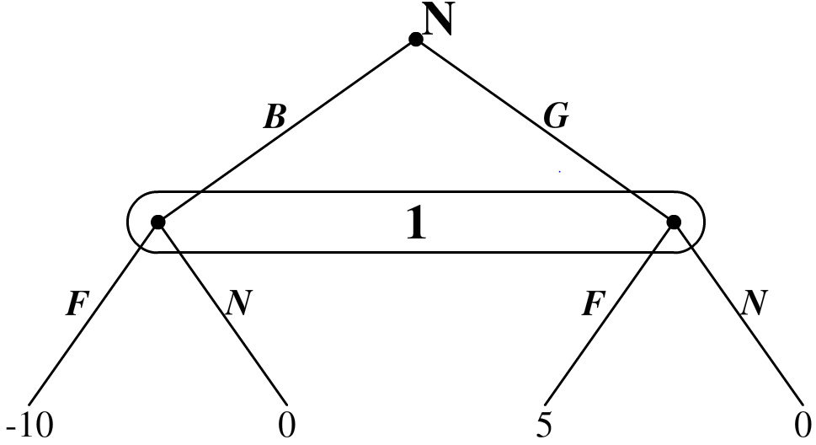
  + U1(F) = -10(1/10) + 5(9/10) = 3.5
  + U1(N) = 0
* Bayesian Game Theory: a game with incomplete information that is modelled using nature as a player
  + Bayesian Nash Equilibria: where each player chooses a strategy that maximizes expected utility given their beliefs and ideas about other players actions
  + Bayesian Normal Form: where payoffs are the expected utility given nature as a random variable
    - Trick: multiply terminal nodes by the probability of nature when finding expected values
  + Example: turn this game into Bayesian Normal Form and find all BNE given conditions for P
    - 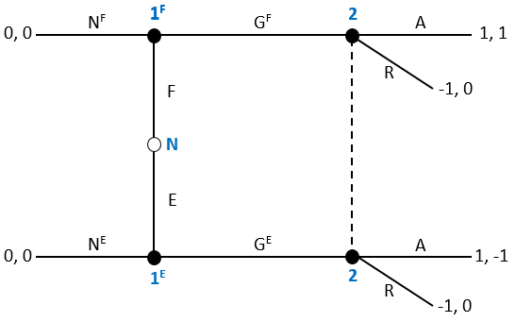
    - Bayesian Normal Form Version: where P = probability F and 1-P = probability of E. P∊(0, 1)
      * 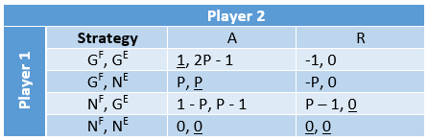
      * (NF, NE; R) is BNE for any P
      * (GF, GE; A) is BNE if P ≥ 0.5
  + Example: write the following game in bayesian normal form and find the pure strategy BNE
    - 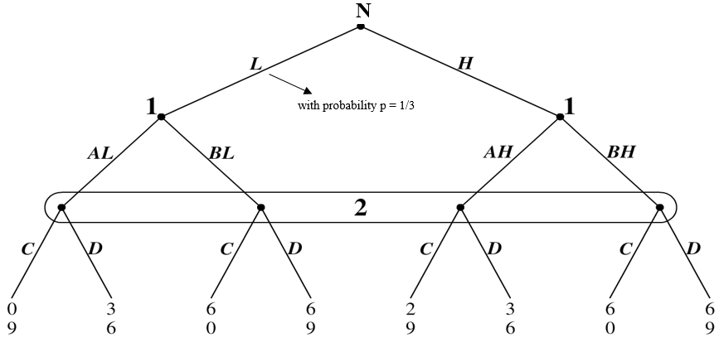
    - Bayesian Normal Form Version
      * 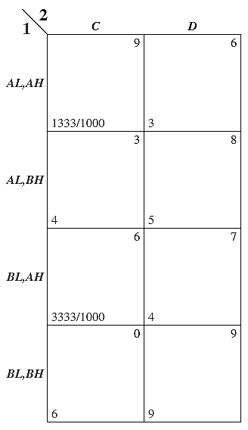
      * Using the underline method, it is clear that (BL,BH; D) is the only pure strategy BNE
* Bayesian Cournot: solving a Cournot game that involves a random variable such as nature
  + Solution Steps: for finding Bayesian Nash Equilibrium quantities
    - Step 1: set up profit functions for each firm
    - Step 2: find the best response functions by taking FOCs to maximize profit
    - Step 3: calculate equilibrium quantities by inserting best responses according to seen costs
      * Doesn’t Know Others Cost: insert other player’s best response into your best response
      * Knows Others Costs: insert the other player’s BNE quantity into best response function
  + Example: the inverse demand in the market for cogs is P = 100 - Q, where Q = q1 + q2. The cost functions for each firm are C1(q1) = 0 and C2(q2) = xq2, where x is known by firm 2 and unknown by firm 1. Nature determines x with the process: x = 0 with prob ½ - or - 40 with prob ½
    - Step 1: set up profit functions for each firm
      * In the low state, firm 2’s payoff is:
        + ㅠ2 = (100 - q1 - q2L)q2L
      * In the high state, firm 2’s payoff is:
        + ㅠ2 = (60 - q1 - q2H)q2H
      * Firm 1’s payoff is weighted by firm 2’s payoffs
        + ㅠ1 = 0.5(100 - q1 - q2L)q1 + 0.5(100 - q1 - q2H)q2 = (100 - q1 - 0.5q2L - 0.5q2H)q1
    - Step 2: find the best response functions by taking FOCs to maximize profit
      * Firm 1: 0 = ∂ㅠ1/∂q1 = 100 - 2q1 - 0.5q2L - 0.5q2H
        + q1 = 50 - 0.25q2L - 0.25q2H
      * Firm 2 Low: 0 = ∂ㅠ2/∂q2 = 100 - q1 - 2q2L
        + q2L = 50 - 0.5q1
      * Firm 2 High: 0 = ∂ㅠ2/∂q2 = 60 - q1 - 2q2H
        + q2H = 30 - 0.5q1
    - Step 3: calculate equilibrium quantities by inserting best responses according to seen costs
      * Firm 1: q1 = 50 - 0.25(50 - 0.5q1) - 0.25(30 - 0.5q1) = 30 - 0.25q1 = 24
      * Firm 2 Low: q2L = 50 - 0.5(24) = 38
      * Firm 2 High: q2L= 30 - 0.5(24) = 18

# Auctions

* Auction categories and Types: the three following categories are combined to form an auction
  + Price Schemes: determines how the price of the good rises or falls
    - English Auction: starts at a low price and goes up
    - Dutch Auction: starts at a high price and goes down
    - Sealed-Bid Auction: simultaneous and independent bids
  + Value Schemes: determines the value the good has for each person
    - Common-Value Auctions: the value is the same for each person and each person bids their signal
    - Private-Value Auctions: each person has their own private valuation of the prize
  + Payment Schemes: determines how each good is paid for
    - All Pay Auction: each person pays their bid
    - First Price Auction: winner pays the bid
    - Second Price Auction: winner pays the second highest bid
* Revenue Equivalence: in most auctions 1st and 2nd price earns the auctioneer equivalent revenue
* Winner’s Curse: conditional on winning the good, I know that my signal was overly optimistic. Unless I take this into account while I bid, then I might overbid and earn negative profit
* First Price, Private Value, Sealed-Bid Auction Example: suppose 2 players are bidding for a prize. Player 1’s value, V1, player 2’s value, V2. Each player knows their own value, but not the other player’s value. V1 & V2 are randomly chosen from the interval [0, 1000] and bi = player i’s bid. ㅠi = player i’s final offer: if player i loses ㅠi = 0, if player i wins: ㅠi = Vi - bi. Each player employs the strategy bi = ∝Vi, ∝∈(0, 1)
  + Step 1: given the random value interval, find the probability of winning as a function of value (V1>V2)
    - P(V1>V2) = V1/1000
  + Step 2: solving for V1 in P(V1>V2), find the probability of winning as a function of bids (b1>b2)
    - V1 = b1/∝
    - P(b1>b2) = (b1/∝)(1/1000) = (b1/1000∝)
  + Step 3: what is player 1’s expected profit, given the probability of winning
    - ㅠe1 = P(b1>b2)(V1-b1) = [(b1/1000∝)](V1 - b1)
  + Step 4: take the first order conditions of expected profit and solve for bi to find ∝
    - 0 = ∂ㅠe1/∂bi = (V1 - 2b1)/(1000∝)
      * ∴ b1 = V1/2 and ∝ must equal ½
* Second Price, Private Value, Sealed-Bid Auction Example: everything is the same as before except the winner pays the second highest bid. What should player’s bid?
  + Step 3: what is player 1’s expected profit, given the probability of winning
    - ㅠ1 = P(b1>b2)(V1-b2) = [(b1/1000)∝](V1 - b2)
  + Step 4: take the first order conditions of expected profit and solve for bi to find ∝
    - 0 = ∂ㅠ1/∂bi = (V1 - b1)/(1000∝)
      * ∴ b1 = V1 and ∝ must equal 1
* First Price, Common Value, Auction Example: there are 2 players and each player receives a signal Yi∈[0, 10] distributed uniformly. If player i wins then ㅠi = (Y1 + Y2) - bi. What is each player’s bid utilizing the strategy bi = Yi
  + Step 1: given the random value interval, find the probability of winning as a function of signal (Y1>Y2)
    - P(Y1>Y2) = Y1/10
  + Step 2: solving for V1 in P(V1>V2), find the probability of winning as a function of bids (b1>b2)
    - Y1 = b1
    - P(b1>b2) = b1/10
  + Step 3: what is player 1’s expected profit, given the probability of winning
    - ㅠei = P(b1>b2)[(Y1 + Y2) - bi] = (b1/10)(Y1 + Y1/2 - b1) = (b1/10)[(2Y1 - b1)/2) = (b12Y1 - b12)/20
      * Note: b1 is set equal to Y1 and Y2 = Y1/2 due to the expected value of uniform distribution
  + Step 4: take the first order conditions of expected profit and solve for bi to find ∝
    - 0 = ∂ㅠe1/∂bi = (1/20)(2Y1 - 2b1)
      * ∴ Y1 = b1 so Bayesian NE is (b1*; b2*) = (Y1; Y2)
* Expected Value of a Uniform Distribution: if something is uniformly distributed, the expected value is the average of the two interval ends
  + Significance: if you win a bid, the other person’s bid is the average between yours and the lowest bid, equal to your bid divided by 2
* Example: suppose player 1 utilizes the strategy b1 = Y1 + 5. What is his expected earning conditional on winning if the expected value is Y1 + Y2 - b1,
  + Y1 + Y2 - b1 = Y1 + Y1/2 - b1 = Y1 + Y1/2 - Y1 - 5 = Y1/2 - 5
    - Therefore do not bid under this strategy and the optimal strategy is b1 = Y1